**Lab 10**

1. *Custom Annotations.* In this problem, you will use an expanded version of the custom annotation @BugReport discussed in the slides to create a small bug-reporting tool. The @BugReport annotation has been expanded for you to include two new elements:

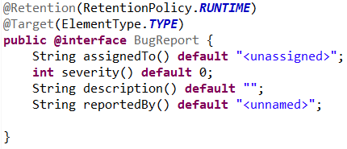

This annotation, together with start-up code for the reporting tool BugReportGenerator and a Main class, can be found in the package lesson10.labs.prob2.bugreporter. You will need to complete the code in the BugReportGenerator, according to the specifications below.

Instances of the annotation have been placed at the class level in each of the classes in the package lesson10.labs.prob2.javapackage, in order to indicate problems that need to be fixed in each of these classes, together with names of the individuals assigned to make the bugfixes. For instance:

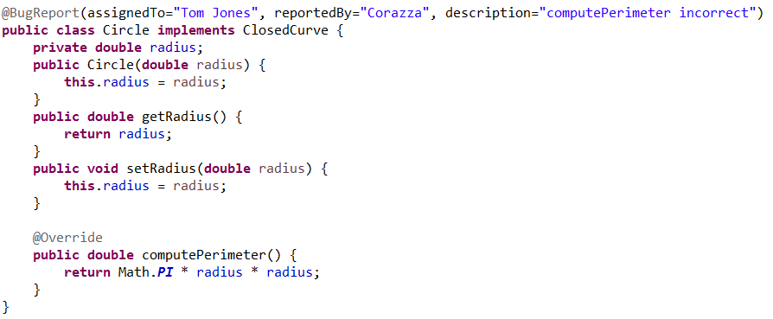

The method reportGenerator in the BugReportGenerator class should do the following:

1. Form a list of all classes in the package lesson10.labs.prob1.javapackage
2. For each class in the package, extract the bug report information supplied by the elements of the @BugReport annotation
3. Create a report that indicates the list of bugs (with detailed information) that is assigned to each bugfixer (format shown below)
4. Output the report to a file bug_report.txt.

For (1), a method ClassFinder.find(**PACKAGE_TO_SCAN**) has been provided for you already; it extracts a list of Classes from a given package; the source for this method can be found in lesson10.labs.prob1.classfinder; it does not need to (and should not be) modified.

For (4), you will need to use a FileWriter (together with a PrintWriter) to output a file. Use the try-with-resources mechanism for creating an instance of these Writers.

When your code is complete and the main method of Main is run, the output file bug_report.txt should look like this:

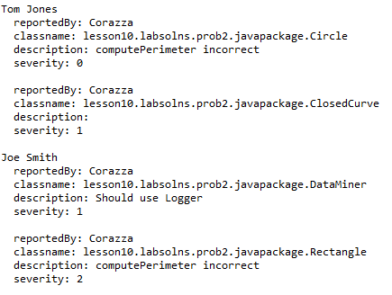

1. In the package lesson10.labs.prob2, the file OldFileIO.java is designed to write a file called "output.txt" into this package . OldFileIO illustrates the pre-Java 8 way of writing a file. Create another Java class NewFileIO that does the same thing, but with some modifications:
   1. You will use the try-with-resources construct to instantiate the necessary Writers (and to handle the closing step in the background).
   2. *Approach to determining the path for the output file*. Think about the best way to do this. Using a URL to specify a file on the classpath (as in InClass exercise) only works for reads. However, do you think it would ever be necessary to write a file to a location on the classpath? (It is not necessary to change the way this output location has been specified in OldFileIO – but if you can think of a better way to do it, then try it.)
2. In the package lesson10.labs.prob3, there is a class FixThis in which a stream map is called which accesses another method that throws an Exception. The code will not compile as it is written. Use one of the Java 8 exception-handling strategies to get the code to compile and run – create a new class FixThisSoln for this purpose. A (commented) main method is provided. Expected output for the first call to processList is

[not, too, big, yet]

However, the second call should throw a RuntimeException.

1. In the package lesson10.labs.prob4, there is a class GuestListPreJava8 which includes a method for extracting (in sorted order) from a list of invited guests (for a particular event) all those guests who have said they will attend the event, who are female, and who are not “illegal.” The implementation has been done using pre-Java 8 techniques. Your job in this exercise is to rewrite the primary method printListOfExpectedFemaleGuests by creating a Stream pipleline and using filters and maps, as necessary. Checking whether a guest is “illegal” involves a checked exception. You will need to use techniques discussed in the lecture to handle this. All the code you need has been provided for you; you only need to write code for the method printListOfExpectedFemaleGuests. Optionally, you may use the PredicateWithException functional interface that has been provided for you in working out your solution (similar to the use of FunctionWithException in the package lesson10.lecture.exceptions2); however, you are not required to solve the problem this way.
2. In the package lesson10.labs.prob5, there are classes Main and Employee. The main method in Main loads a list of Employee s and then attempts to print, in sorted order, the full names of those Employees whose salary is greater than 100,000 and whose last name begins with any letter that comes after ‘M’ in the alphabet. This exercise asks you to refactor this processing step in the main method so that it can be unit tested, using the techniques mentioned in the Lesson. Do the following:
   1. It is difficult to test an expression that simply prints to console. Move this processing step into two methods, asString(List), which does the same processing, but returns a String rather than printing to the console, and printEmps(List), which calls asString and then prints the string to the console. Replace the processing step in the main method with a call to printEmps.
   2. Create two packages, soln1, soln2, where you will put the two different types of solutions you will develop for testing this code.
   3. In soln1, create a JUnit Test class that tests the asString method. Make sure you test with a few Employee instances so that at least one Employee is excluded from the list and at least one is included in the list. This is an example of the Simple approach mentioned in the slides.
   4. In soln2, refactor the asString method so that method references are used to call auxiliary methods, as in the Complex case described in the lecture. Create auxiliary methods salaryGreaterThan100000(Employee e) and lastNameAfterM(Employee e) for this purpose. Then create a Test class in soln2 that tests these auxiliary methods, along with the fullName(Employee e) method. Does this approach provide a good test for the asString method?

6. In the package there is a class Queue. Do the following:

1. Show that Queue is not threadsafe by setting up a multithreaded environment in which you create a race condition.
2. Modify Queue so that it is threadsafe, and verify in your test environment that you have been successful.